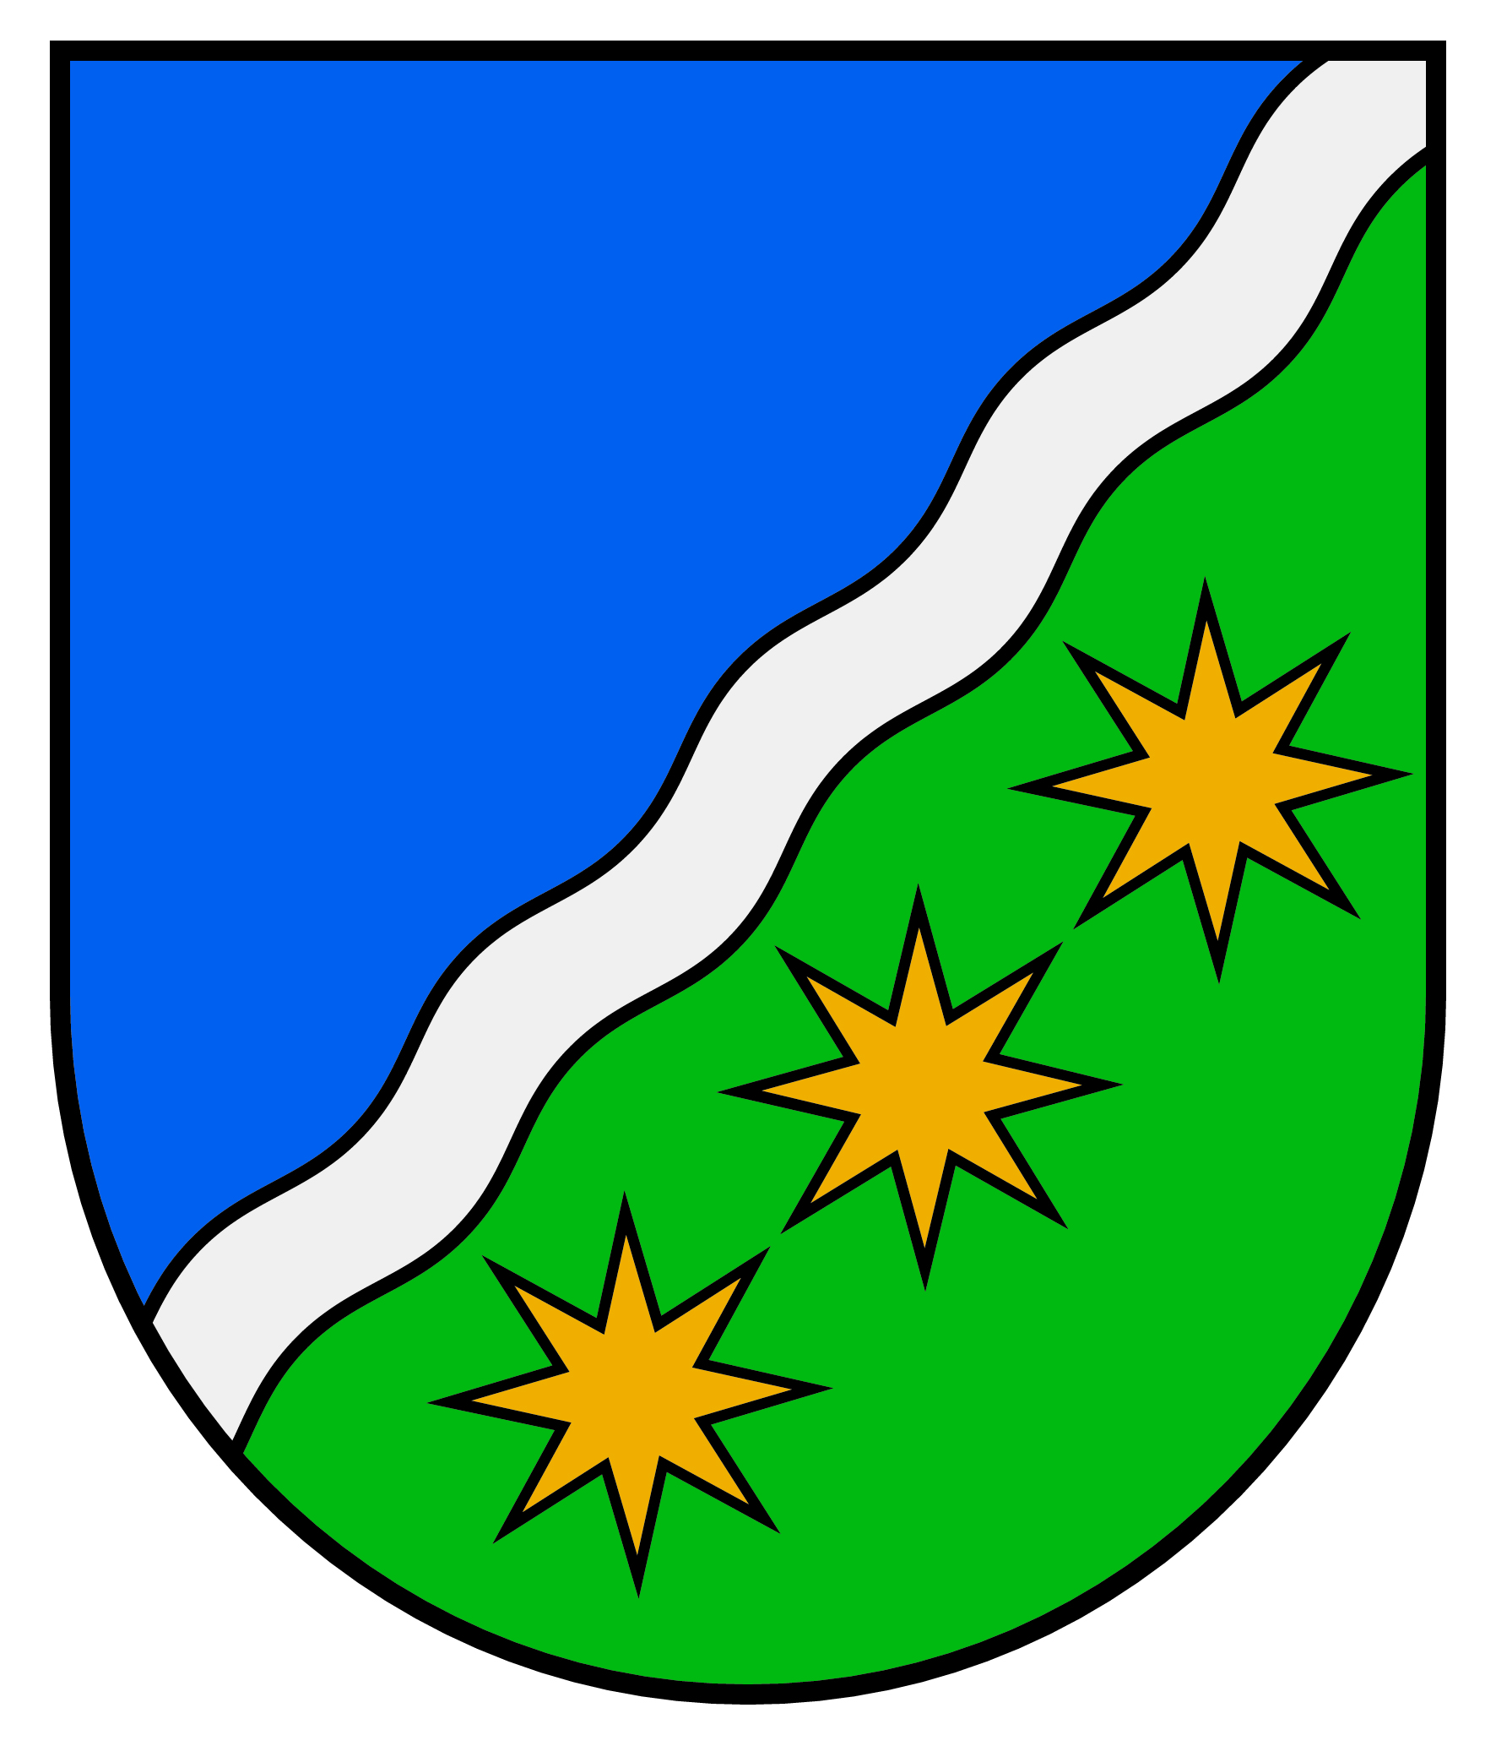
Ķekavas novada pašvaldības
Apbalvojums “Ķekavas novada Goda pilsonis”

Pieteikums
Pretendents
Vārds, uzvārds ……………………………………………………
Dzimšanas datums ………………..……………………………….
Nodarbošanās ……………………………………………………..
Dzīvesvieta ……………………………………………………….
Kontakti (tālr., e-pasts) …………………………………………….

Pretendenta dzīves gājuma apraksts
(panākumi, sasniegumi vai ieguldījumi, kas uzskatāmi par nozīmīgu devumu
Ķekavas novadam)
................................................................................................................................................................................................................................................................................................................................................................................................................................................................................................................................................................................................................................................................................................................................................................................................................................................................................................................................................................................................................................................................................................................................................................................................................................................................................................................................................................................................................................................................................................................................................................................................................................................................................................................................................................................................................................................................................................................................................................................................................................................................................................................................................................................................................................................................................................................................................................................................................................

Informācija par pieteicēju
......................................................................................................................................................................................................................................................................................................................................................................................................................................................

Pieteikums jāiesniedz līdz 2015. gada 1. oktobrim Apbalvošanas komisijai.
Vairāk - www.kekavasnovads.lv.

